Hannam Vale Public School
Proudly a NSW Public School

Excellence, innovation and student success in
a caring community

By Learning We Conquer

A 1159 Hannam Vale Road, Hannam Vale NSW 2443 T (02) 6556 7636 F (02) 6556 7672
E hannamvale-p.school@det.nsw.edu.au


Issue 36: 2012 - Term 4 - Week 9 “A proud member of the Camden Haven Community of Schools”

Tuesday 4th December 2012

Thank you everyone for making last Thursday a resounding success. It couldn’t have been more perfect. I have seen quite a few presentation nights in my time, but last Thursday was not just the best, but it makes all the rest pale in comparison!

It was a wonderful family evening. A huge thank you to all who bought food to share, the quality and variety would rival the cuisine of any five star restaurant!

Thank you to the P&C for providing the sausages and drinks and working so tirelessly to ensure we were all well fed and watered.

I am reserving my biggest thank you to the students. I could not have been more proud of their exemplary behaviour and their effort and execution of the myriad of roles they had to perform on the night to ensure a seamless performance. They excelled. Awesome job kids!!!!

If anyone has some really good photos of the night could you please let me have an electronic copy.

There are only 2 ½ weeks until the end of term (for the students), could you please start returning library books, class books and any other items belonging to the school or teachers that the children have borrowed over the year.



Swimming

It appears that the first week of swimming will be a hot one (although not quite as hot as last week). Please ensure your child brings a rash shirt or T-shirt and a hat that can be worn in the water. Changing can be chaotic, so please make sure that all items of clothing are named.

If your child is likely to get sore eyes from the chlorine, please send named swimming goggles and or eye drops with clear administration instructions.

Swimming Carnival & BBQ Friday 14th December

We need to know numbers for this event to enable Johns River Public School to cater for the BBQ. A sausage sandwich with a drink will cost $2.50. Please let Katie know how many adults and children will be ordering.

Reports

Reports will go home Friday week. If you wish to discuss your child’s report with me or Mrs Jones please make an appointment for the following week. (Both Mrs Jones and myself will be at the school up to and including Friday 21st December).



End of year party

Everyone is invited to our end of year party on the last day of term, Wednesday 19th December. Please bring a plate of food to share. Secret Santa presents will be given out at the party (each child has drawn a name of another child to buy an anonymous gift not exceeding $5 in value) and the year 6 students will unveil their gift to the school.

After the food we will be having water play, so bring along your super soaker water pistols and wear clothing that can get wet. I have arranged for the RFS to pay a visit and assist in the water theme by allowing the children (adults welcomed too!), to run in and out of the spray from their hoses. It should be a fun way to end a very exciting, eventful year.

Next week’s newsletter will be the last one for the year and my final one before I leave.

Chris Armour
Relieving Principal

UPCOMING SCHOOL EVENTS

Dates | Term 4
17.12.12 | Kindy Orientation – Full school day
18.12.12 | Year 6 Farewell Dinner
19.12.12 | End of Year School Party

REGULAR EVENTS

Tuesday morning | Student Banking  Please hand in to the office before school
Mon, Wed | School Fitness program  First 20 mins in the mornings
Wednesdays | Waste-free eating breaks
Fridays | Student homework to be returned to school
Fridays | Sport Session first hour of the day
Fridays | Scripture 12.30 pm

P & C NEWS

POWERBALL
Congratulations to Jake Mison who was our Powerball winner for last week!

PRESENTATION NIGHT
Thank you everyone for a wonderful night last Thursday. The children had a great time and it was wonderful to see so many parents/grandparents socialising and enjoying themselves also.

Thank you to all the contributors of the delicious culinary treats and thanks for the help setting up, serving and washing dishes. Well done to the school staff for hosting a great Presentation Night. As the saying goes – “Let’s do it again – soon!”

CHRISTMAS RAFFLE
We have a new donation for our raffle. Bunnings Taree have kindly donated a $50 gift voucher. So keep selling those tickets as the prize pool is looking fabulous!
I will be selling tickets this Saturday at Lakewood shopping centre, so if you have a spare half hour or so I would be grateful for the help.

NEXT P&C MEETING
Wednesday 12th December 3:10pm till 4pm at school.

MINUTES OF LAST MEETING attached.

Michelle Dennis
P&C President
STAR OF THE WEEK!!!
Jasmine Trafford
Year 2

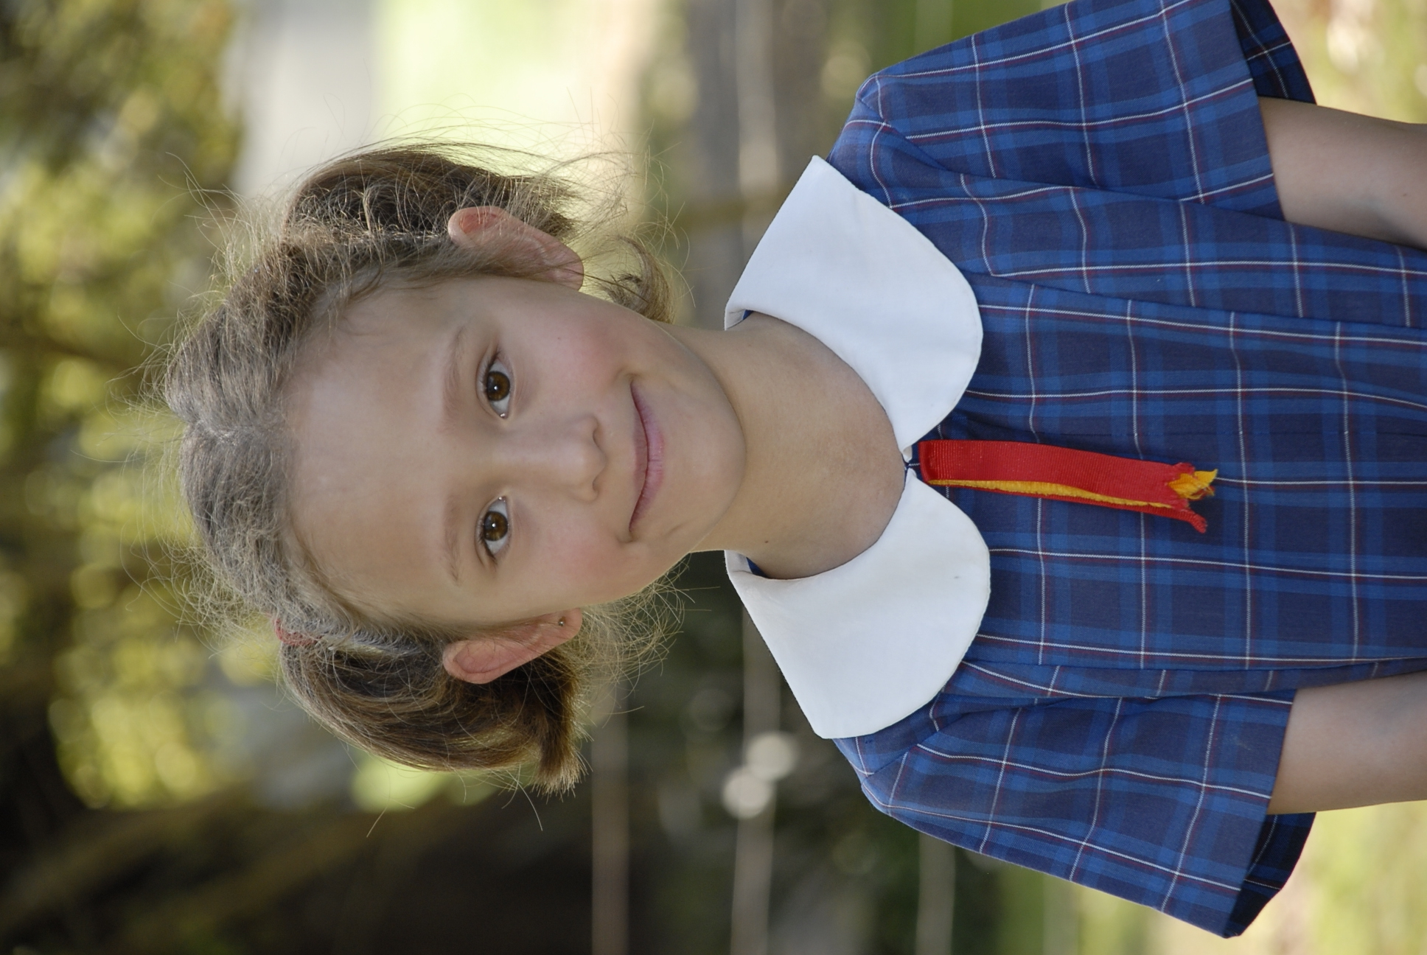

So, Jasmine, how do you feel about being chosen star of the week?
Great!

Why were you chosen for this award?
For good handwriting.

Who are your best friends?
Lily-Rose, John, Lewin, Sam and Josh.

Where were you born?
At the RPA in Sydney.

Do you have a nickname?
Jazzey, Bazzey

What do you want to be when you grow up?
A singer.

OK Jasmine, thank you for being interviewed by HV Press.
by Reporter – Connor McInnes

☺☺☺☺☺

CBA STUDENT BANKING

BANK SOME MONEY AND YOU COULD BANK YOURSELF AN IPAD MINI!!!

Simply making a deposit through your School Banking before Friday 14 December will put you in the draw to win one of twelve (12) iPad Mini’s valued at $369 each for Christmas.




Enrolments - 2013
Enrolments are now being taken for 2013.
Please contact the school for further information

